No. of Pages | 3
No. of Questions | 3

Department of Computer Science and Engineering
MIDTERM EXAMINATION Summer 2017

CSE421: Computer Network
Total Marks: 45 Time Allowed: 55 minutes
- Answer ALL THREE (3) questions
- Figure in bracket [] next to each question indicates marks for that question

Question 1
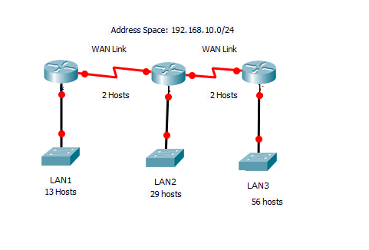
Figure no. 1

- Suppose a company is given a block 192.168.10.0/24. But you need three more sub networks for your organization and two more for the WAN Links as shown in figure no. 1. Show how you can have 5 more subnets out of the original network address as per host requirements. Do not forget to show basic calculations. [10 marks]
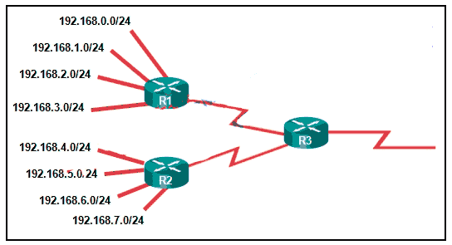
Figure no. 2

Figure no. 2
- Refer to the topology in Figure 2. What should be the static summary routes and where should we apply them? [4 marks]

- A router has the following information regarding its default route, why does it have 3 default routes, which one will it use and why? [4.5 marks]
  - S 0.0.0.0/0 [1/0] via 200.20.20.1
  - S 0.0.0.0/0 [5/0] via 201.21.20.1
  - S 0.0.0.0/0 [8/0] via 192.168.10.10

Question 2

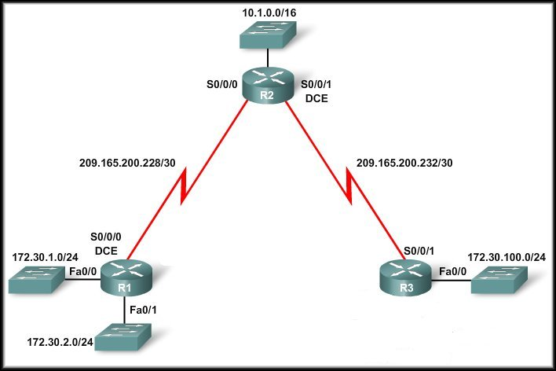
Figure no. 3

- Given Figure no.3 shows a discontiguous network. The Auto-summary must be disabled. Now write down the process in full for disabling the auto-summary. [4]
- Write down the difference between RIPv1 and RIPv2. Define different types of timer for RIP. [3+3=6]
- What is the process (commands) for static summary route in RIP routing? Why we use passive Interfaces? [3+2=5]

Question 3

- State what packets are exchanged during the link state routing algorithm? And also what information do they contain?

- A serial link is operates at 128 kbps. The network administrator used the clock rate command to set to 128000 on the serial interface. The bandwidth and cost commands are not used. What will be the calculated OSPF cost for the link?

- Refer to the multi access networks shown in figure no. below. For each router find their router ID. And also find the DR/s and BDR/s.
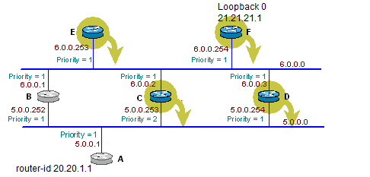

THE END

